Table of Contents
1. PROCESS NAME AND OWNER 3
a) DOCUMENT ISSUE / STATUS 3
2. PROCESS OVERVIEW 3
3. PROCESS OBJECTIVES 4
4. ASSUMPTIONS 4
a) ACRONYMS 4
5. KPI 4
6. PROCESS DOCUMENTS 4
7. PROCESS MAP 5
8. PROCESS ACTIVITY DETAIL 6
9. PROCESS SIGN OFF 12

PROCESS NAME AND OWNER

a) DOCUMENT ISSUE / STATUS

PROCESS OVERVIEW

The Accounts Payable Associates are responsible for processing direct invoices to ensure that payments are processed on time. Once the stock has been ordered, the supplier will provide a PDF invoice with the stock details (Quantity, Price per unit, Description, etc.) to the divisions designated mailbox.

It is the Associate’s responsibility to process the invoice within Procure and identify any discrepancies that the Requisitioner needs to be aware of. Once the invoice has been approved, it will then be imported into Sage to await posting.

When the stock has been delivered, the ASN will detail what is on the pallet and which PO they relate to, this will enable the warehouse to book the stock in correctly. If the ASN is not provided or the delivery is out of the agreed time slot, the goods will be rejected, and the supplier will be required to re-issue the invoice when the goods have been re-delivered. The warehouse will then complete the necessary checks to ensure that we receive the correct quantity and the goods have not been damaged in transit.

PROCESS OBJECTIVES
The objective of this process is to document the ‘as-is’ for processing direct invoices through Procure. This will reduce late payment fees, complaints, and legal action being taken against XXX. This process will also ensure that our ledgers are fully up to date and auditable.

ASSUMPTIONS
- Users have access to Outlook, Sage, Procure & SharePoint.
- The user has been fully trained in the end-to-end process.
- The user can identify the BP, PO, stock quantity and price from the invoice.

a) ACRONYMS

No. | Acronym | Description
1 | AP | Accounts Payable
2 | INV | Invoice
3 | CNV | Credit Notes
4 | BP | Business Partner
5 | GL | General Ledger
6 | CC | Cost Centre
7 | BU | Business Unit
8 | PO | Purchase Order
9 | GAS | Global Accounting Services
10 | SEQ | Supplier Error Quantity
11 | QEP | Query Error Price
12 | IEP | Internal Error Price
13 | SEP | Supplier Error Price
14 | LEP | Invoice Price Lower than PO
15 | ASN | Advanced Shipping Notice
16 | KPI | Key Performance Indicator

KPI
Average cost per invoice calculated monthly and reported within the Group SSC KPI Pack

PROCESS DOCUMENTS

PROCESS MAP
Direct Procure Invoice Processing
Phase
Accounts Payable | 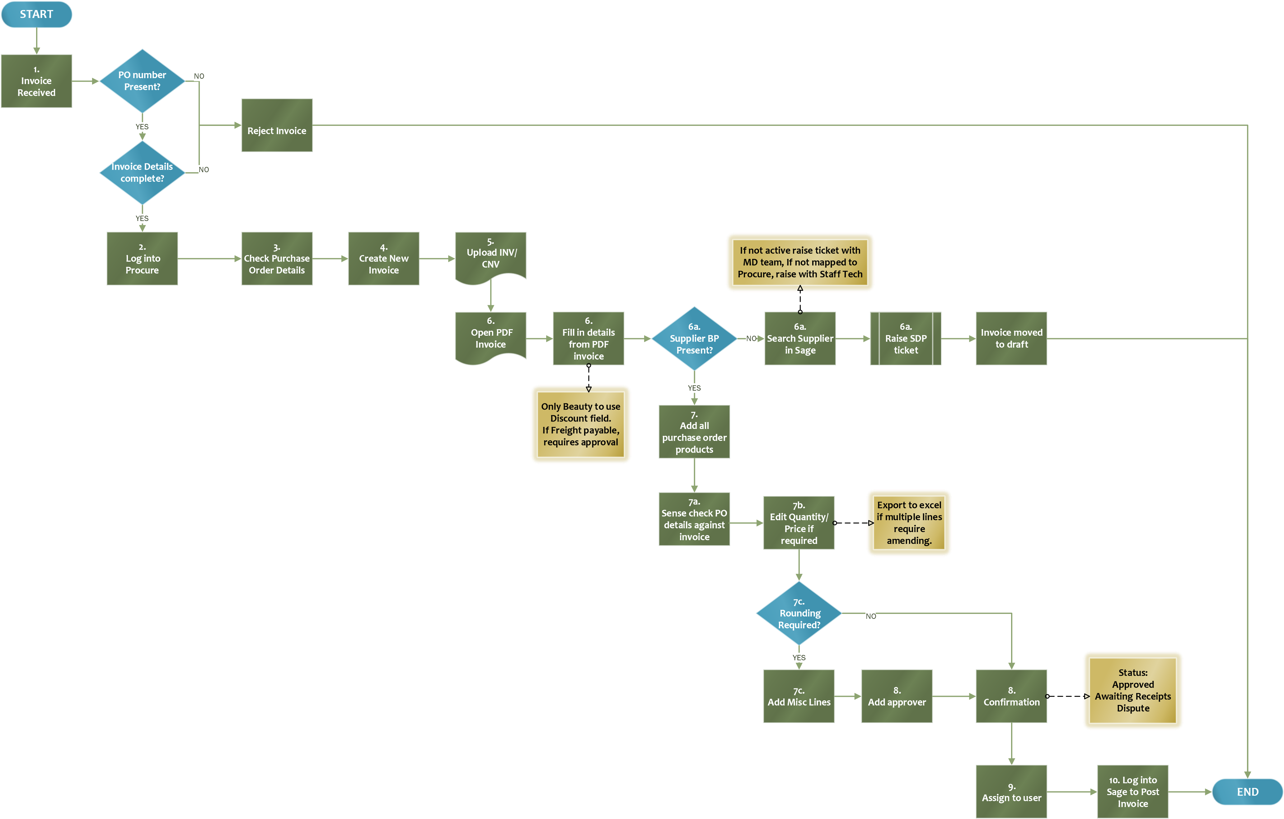

PROCESS ACTIVITY DETAIL

Start: The Requisitioner will request stock by raising a requisition through Procure and sending it for approval. Once approved the requisition will convert to a purchase order and the supplier will be sent the purchase order via an email. The supplier will deliver the stock, create a PDF invoice, and email this invoice to the designated mailbox.

- Open the shared mailbox that stores the invoices that require processing. All invoices should be submitted in PDF format by the supplier. Download the invoice as this will need to be uploaded into Procure.

Prior to processing the invoice, sense check the information provided ensuring that there is a visible PO number, and all invoice details are completed. If not, reject the invoice by responding to the supplier email advising them to resubmit with the appropriate information. If they are unsure of the information they are required to provide, they should contact their xxx buyer.

- When ready to process the invoice, access Procure by logging into Okta and selecting ‘xxx Procure -User’. Once open, save the link to your bookmarks for easy access in the future. Click ‘Log in with xxx’ to bring you into the user application.

‘direct Purchase Orders’ to identify which BP the PO relates to.
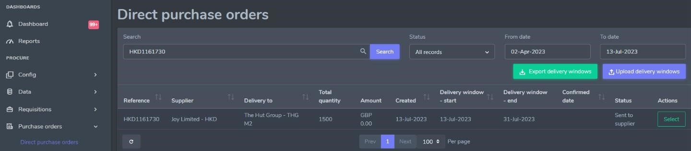
- Once the PO details have been reviewed, within the home page, go to Invoices to release the two available drop downs and select ‘Direct Invoices’. Search the invoice number to ensure it hasn’t been processed already, remembering to amend the date and deselect ‘assign to me’. If no matches are found, click ‘+ Create New Invoice’.

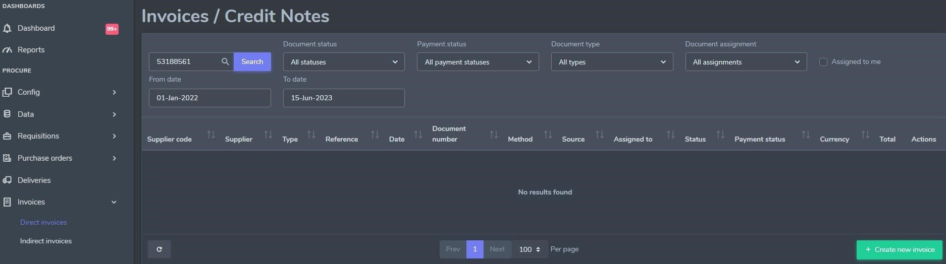

- Drag and drop the PDF invoice or click in the box to upload from your desktop. Click ‘Next’ once uploaded.

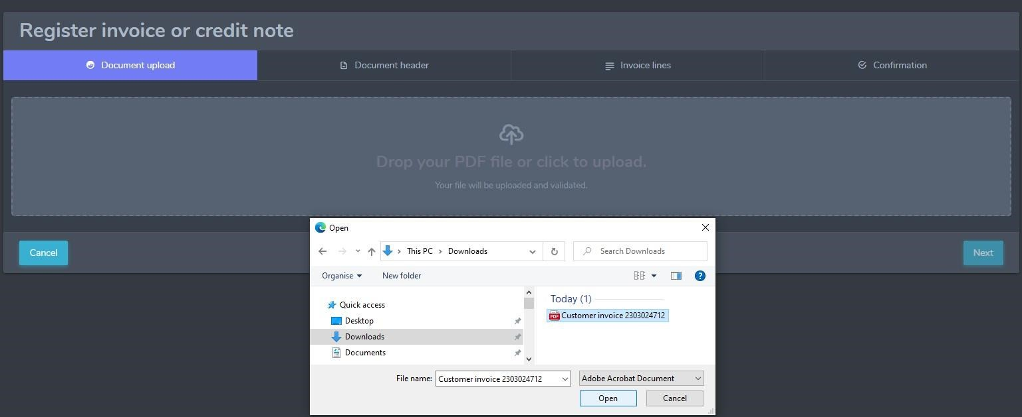
- Open the PDF invoice to enable you to fill in the mandatory fields within the <Document Header> tab.

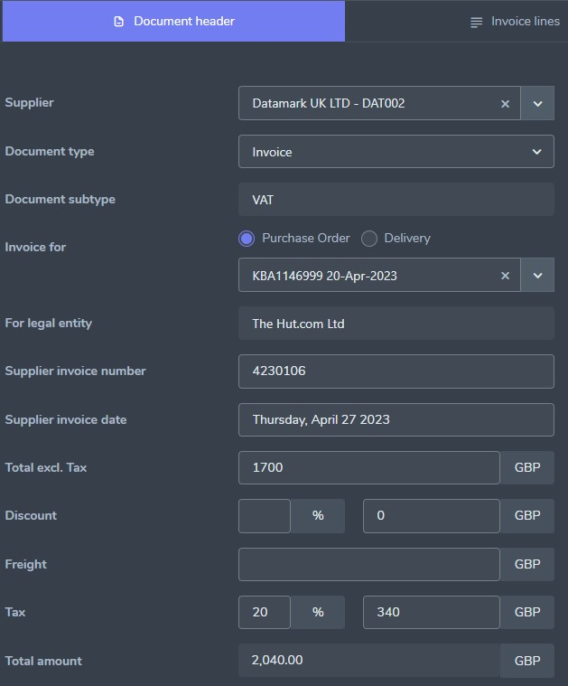
C

D

E

F

G

B

A

6a. When selecting the Supplier, if they are not present in the drop-down list, search the company name in Sage. If the ‘Active’ box, does not have a tick, this means the account has been de-activated. In this instance, raise a ticket with the Master Data team to request the supplier be re-activated.

If the supplier is active, raise a ticket with Staff Tech to get the account mapped to procure.

Note: Once the document header has been completed, a pop-up message will appear stating ‘Draft Created’. This means that the Associate can close the registration and resume at a later date without losing the information that has already been provided.
- Within the <Invoice Lines> tab, if the product details have not been populated, click ‘Add all Purchase order products’ to bring up the PO lines.
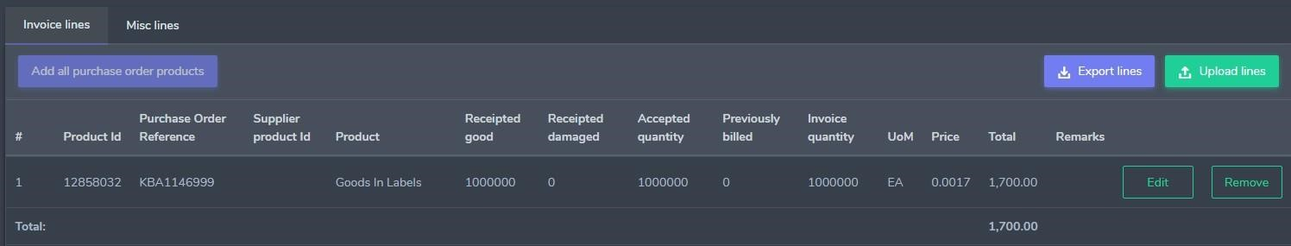

7a. Sense check the PO product, invoice quantity, price and total against the invoice to ensure that they are a match. When confirmed as a match, the status will show as ‘Approved’ and the Associate can move onto the next tab for the final confirmation.

Amending purchase order details to match the supplier invoice.

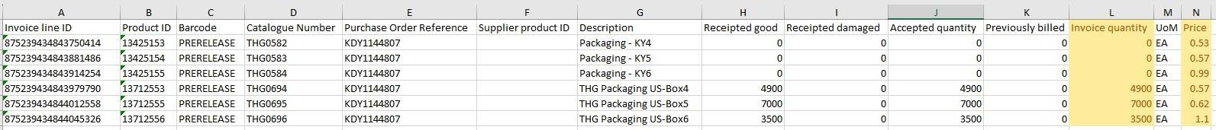
7b. If there are discrepancies in the invoice value and/or quantity, click into ‘Edit’ to amend the price/quantity to what the invoice states. If the order has not been receipted, the invoice will automatically be moved into the status ‘Awaiting receipts’, otherwise it will be categorised as
‘In Dispute’, where the Requisitioner will review and either approve or reject the discrepancies.
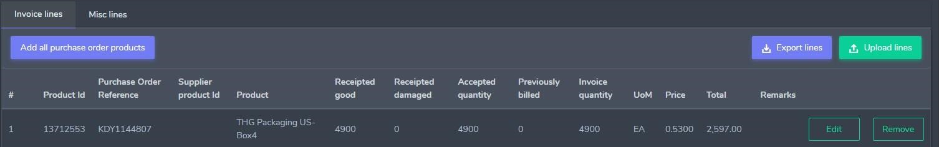

If there are multiple lines on the PO, click into ‘Export Lines’ to convert the data into excel for manual amendments. Only columns L and N are to be amended. If there are lines that do not relate to the invoice, simply amend the quantity to 0. Save the excel file and re-upload the lines to update in Procure.
7c. On occasion, there may be a difference in the pricing due to a discount or the value on the invoice going to 5 decimal places. In this instance, go into <Misc Lines> and click ‘+ Add rounding’. Add in the difference in value and save. Anything over £20 will require approval. Please refer to the approval matrix. Approval Matrix
- Within the <Confirmation> tab, if required, add the approver details, then tick the below box to confirm that the PO has been matched correctly against the invoice.


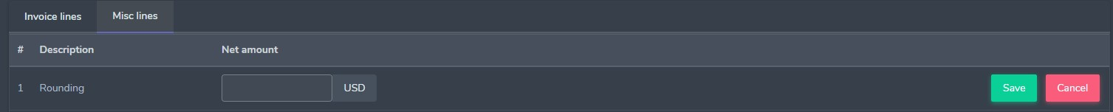

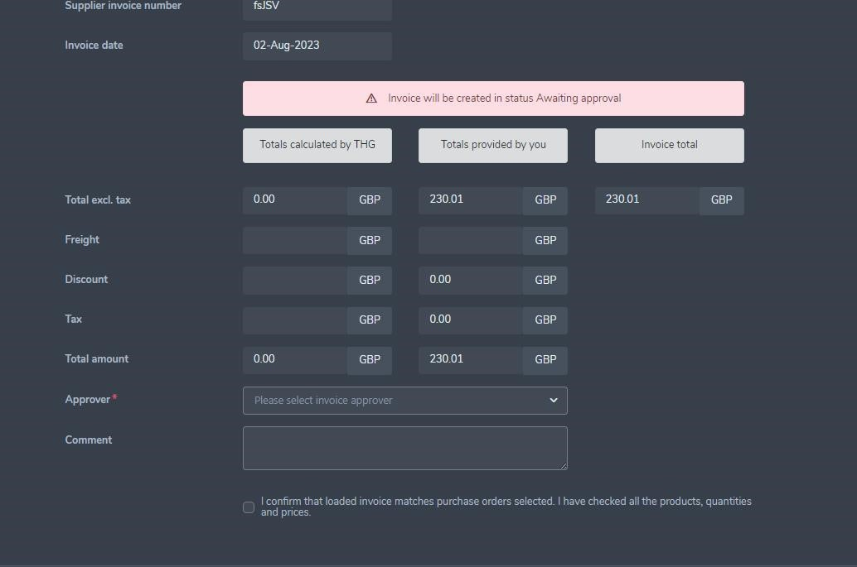

If the PO has been receipted, the invoice status will be set as ‘Approved’ and imported into Sage to await posting.
- Once the invoice has been processed through Procure, assign the document to a user. This is to support the Associate in tracking the status of the invoice if not yet approved/receipted.

Search for the invoice by returning to <Direct Invoice> and entering the invoice number into the search bar. Ensure that the dates are set correctly and ‘assign to me’ is not ticked.



Go to ‘Assign to’, enter the Associates name and click ‘Save’.

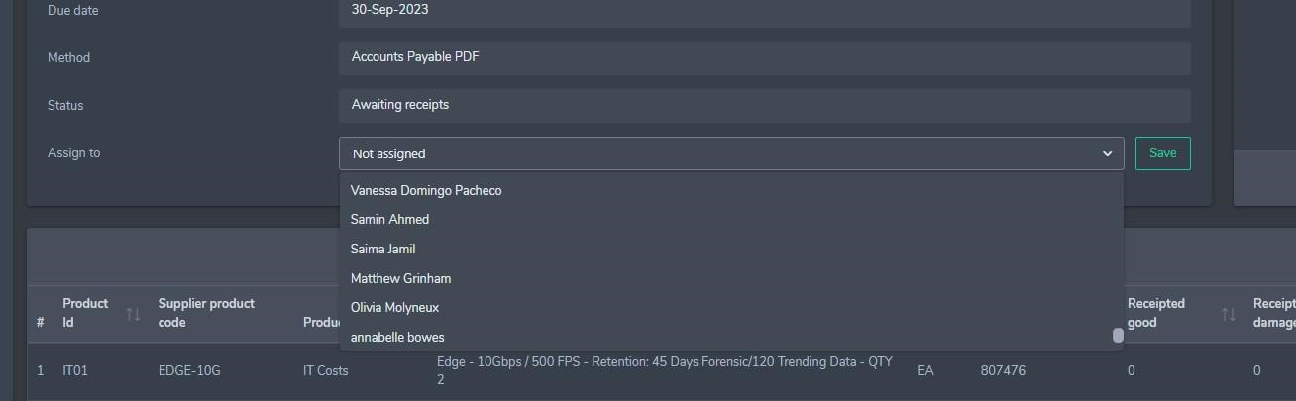

Note: To track the status of the invoices that are not yet approved, return to <direct invoices> and ensure the ‘assign to me’ is ticked - click search and this will bring all invoices that are currently assigned to you.

9. Log into Sage and navigate to Purchasing>Invoices>Invoices>Full Entry.

Search the invoice number in ‘Supplier document’ to bring up the invoice detail and click ‘Post’.

